Using “ASTERIX” in accident investigation
Transforming raw radar data to answer investigative questions
PAUL FARRELL (MO5491) - Inspector of Accidents - Air Accident Investigation Unit, Ireland
MICHIEL SCHUURMAN (MO4721) – Senior Air Safety Investigator - Dutch Safety Board, The Netherlands
Paul Farrell – Inspector of Accidents - Air Accident Investigation Unit, Ireland
Mr. Farrell has a Bachelors Degree in Engineering from Trinity College, Dublin, and a Masters Degree in Safety and Accident Investigation (Air Transport) from Cranfield University, UK. For 24 years he served as an Aeronautical Engineer Officer in the Irish Air Corps, the last seven of which were as the Chief Aeronautical Engineer. Throughout his Military career he was responsible for accident and incident investigation, including several fatal accidents. He left the Military in 2009 to take up a position as an Inspector of Air Accidents with the Irish Air Accident Investigation Unit, where his responsibilities include downloading and analysis of flight data and voice recorders as well as the analysis of relevant ATC recordings.
Michiel Schuurman– Senior Air Safety Investigator - Dutch Safety Board, The Netherlands
Mr. Schuurman has a Masters Degree in Aeronautical Engineering from the Technical University Delft, The Netherlands. As an ISASI student member he was awarded the first ISASI Rudy Kapustin scholarship award in 2003. In 2005 he joined the Dutch Safety Board as an Engineering Investigator and recently became a Senior Air Safety Investigator. Primary responsibility at the Board include conducting accident investigations, performing accredited representative duties, analyzing flight recorder data and other electronic recorded data which is not limited to Aviation. In 2009 he was the flight recorder group chairmen for the of Turkish Airlines flight 1951 accident near Amsterdam.

RADAR data and accident investigation
The value of RADAR data to aid in the investigation of air accidents has long been recognized. For completeness and by way of introduction a brief review is presented here to provide some orientation.
In 1982 Stephen J. Corrie presented a paper to ISASI entitled “The use of Air Traffic Control RADAR as a tool in Accident Investigation”. Corrie identified the various components within the ATC RADAR system and how these components interacted. He discussed the data provided and explained how that data could be processed to derive additional information (e.g. flight path estimation) of use to the investigator. He catalogued a number of accidents involving Gates Learjet aircraft and explained how RADAR data was instrumental in developing an understanding of the actual flight dynamics of these aircraft which departed cruise altitude and impacted terrain. Corrie concluded:
In using ATC radar data with real-time input, the investigator can determine with reasonable certainty the aircraft’s position in space. Its ground track, flight path, average ground speed, and rate of climb or descent can also be calculated. Furthermore, knowledge of existing wind direction, speed and ambient temperature will permit determining Mach number, true and indicated airspeed.
In 1994, Roberts, McLeod, Vermij, Heaslip and MacWilliam presented a paper to ISASI entitled “RAP (Radar analysis program) An Interactive Computer Program for Radar Based Flight Path Reconstruction and Analysis”. This paper described techniques used to analyse and smooth radar data for reconstruction purposes, addressed issues around system timing delays and documented flight test validation of the algorithms used.
Sweggenis and Wood (2007) devote a chapter (19) to the use of air traffic control data. They identify six headings under which the investigative uses of radar data should be considered; Flight path; Aircraft Performance; Missing Aircraft; Structural Failure; Accident Sequence and Mid-air Collisions.
These examples of previous work serve to illustrate the invaluable uses of RADAR data to the accident Investigator. This paper will provide Investigators with an introduction to a data standard in use by many of the Eurocontrol national authorities (ASTERIX) and will consider and explore how the use of this standard can be of assistance to the accident investigation community. It will be shown that ASTERIX has several component specifications (Categories) each of which has certain strengths, depending on the nature of the event under investigation. This paper will introduce several of the most useful ASTERIX categories and discuss their recent use in investigations.
Before introducing ASTERIX it is prudent to remind ourselves of the two types of returns which will be encountered when dealing with radar data:
Primary Radar: A Radar in which the return signals are the echoes obtained by reflection from the physical target (the aircraft).
Secondary Radar: A Radar in which the return signals are obtained from a beacon, transponder, or repeater carried by the physical target.
Introduction ASTERIX
ASTERIX is the EUROCONTROL Standard for the exchange of Surveillance related data. The acronym stands for "All purpose STructured Eurocontrol suRveillance Information eXchange". ASTERIX provides a structured approach to message formatting which is applied in the exchange of surveillance related information for various applications. Developed by the suRveillance Data Exchange Task Force (RDE-TF) with its multinational participation, it ensures a common data representation, thereby facilitating the exchange of surveillance data in an international context.
ASTERIX is an application/presentation protocol responsible for data definition and data assembly developed to support surveillance data transmission and exchanges. Its purpose is to allow a meaningful transfer of information between two application entities using a mutually agreed representation of the data to be exchanged. The ASTERIX Standard refers to the Presentation and Application layers (layers six and seven) as defined by the Open Systems Interconnection (OSI) Reference Model (International Standards Organization (ISO) Standard 7498) [ISO/IEC 7498-1: 1994 [ITU-Rec.X.200 (19940] Information Processing Systems - OSI Reference Model - The Basic Model].
Philosophy of ASTERIX
The philosophy of ASTERIX can be described in two short phrases:
"Distribute everything as required" and "Do not transmit more than necessary"
ASTERIX has been designed as a flexible way of encoding surveillance related information to be exchanged between users. It is characterized by the grouping of information in data categories and the flexible generation of messages in order to save bandwidth in the transmission.
For the various applications within the surveillance domain, individual data categories are defined. This allows the designer of a system to implement exactly what is needed, no more and no less. The software to be implemented can be tailored exactly to the function of the respective system. Should additional functionality be required at a later stage, the necessary interface can easily be added by augmenting the ASTERIX category defined for the specific application.
The same flexibility applies to the generation of the ASTERIX message itself. Subdividing the complete set of possible information into individual data-items, a message can be composed according to the information available. Items carrying no information are simply omitted when creating the message. The FSPEC, a sort of "Table of Contents" for each ASTERIX message, precedes the data items, indicating unambiguously to the receiving system those data items that are present and those which are not. This allows the processing to be adapted to the real message contents. There is no need to transmit useless bits and bytes or to skip unwanted information in a message.
The sequence of items in the message is defined in the co-called “User Application Profile” (UAP). It is the task of the “suRveillance Data Exchange Task Force (RDE-TF)” to manage and co-ordinate the maintenance and evolution of existing and new ASTERIX categories, as and when required. In most cases this will be triggered by the launch of a new application (such as ADS-B or Multi-Lateration) or by the need to adapt an existing category to changing needs. In any case, the fact that this process is controlled by a body composed of members of most Air Navigation Service Providers (ANSPs) ensures that the results (e,g.a new ASTERIX category), is universally accepted and forms the specification against which later implementation(s) will be validated.
What is a Category?
To implement the ASTERIX data format in a structured way, the set of documentation has been subdivided into Parts, each of which deals with the data for a specific application and purpose.
Each ASTERIX Part contains one or more Data Categories. The information contained in these categories addresses a specific area of application and defines which data in what format is to be transmitted between the users of this application. Each category consists of a Catalogue of Data Items, the Data Item being the smallest unit of standardized information.
This categorization serves three purposes:
- it is easy to identify the application
- dispatching of the data to the appropriate task within the receiving system is facilitated
- only the category(ies) for applications in the user system have to be implemented.
A total of up to 256 Data Categories can be defined and their usage is as follows:
- Data Categories 000 to 127 for standard civil and military applications;
- Data Categories 128 to 240 reserved for special civil and military applications;
- Data Categories 241 to 255 used for both civil and military non-standard applications.
For Data Categories 000 to 127, the responsibility for the allocation of the number rests with the suRveillance Data Exchange – Task Force (RDE-TF), with endorsement from the Surveillance Team (SURT).
For Data Categories in the range from 128 to 240, the allocation of the category number is delegated to the issuing authorities. In future a closer co-ordination with EUROCONTROL is envisaged wherever possible.
The specifications for the ASTERIX data categories (CAT) form part of the ASTERIX Standard Document. A current list of the ASTERIX documents is available through the EUROCONTROL website : http://www.eurocontrol.int/asterix/public/standard_page/documents.html
ASTERIX data block structure

All ASTERIX data is transmitted in a data block using the CAT specification. An ASTERIX data block consists of:
• a one-octet field specifying the Data Category (CAT)
• a two-octet field block Length Indicator (LEN)
• one or more Record(s).

The one octet field Data Category (CAT) indicates to which category the transmitted data belongs to. Next the two octet field indicates the total length (in octets) of the Data Block including the CAT and LEN fields. An analogue of the ASTERIX block is the description of a library bookshelf. The LEN field indicates the number of books that are on the bookshelf.

ASTERIX data blocks comprise multiple records of the same CAT; both block and records have variable lengths. Each record starts with one or more field specification (FSPEC) octets which described the data items (fields) that are embedded in that particular record. The FSPEC can be compared to a table of content of a book, and indicates the data items which are recorded in that specific record. After the FSPEC the fields for the individual data items follow. A detailed description of the ASTERIX format is given in: http://www.eurocontrol.int/asterix/gallery/content/public/documents/pt1ed130.pdf

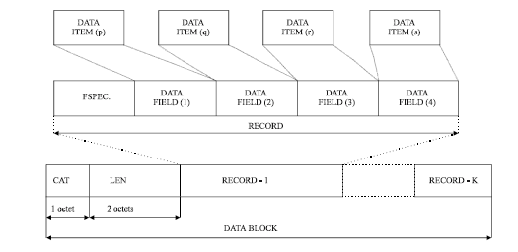

Figure 1: Overview of the ASTERIX data block structure.
Presentation of radar data
Data received from airport sensors (radar) is processed and converted to targets which are shown on a controller’s Plan View Display (PVD). An aircraft, vehicle or other obstacle can be a target and these (multiple) targets create an image or air situation picture. An aircraft target with a transponder can further be enhanced with other information included but not limited to call sign, aircraft type, altitude and speed. Each controller has a PVD, but the range, labelling and details are dependent on the task of the controller.
Not all sensor data is transformed to information which is displayed to the controller. Certain information is not useful for the controller’s task of directing air traffic therefore it is not displayed. To achieve a smooth data display for the air traffic controller additional filtering and extrapolation of aircraft track data is usually implemented. Due to computer hardware limitations and features required by controllers the application software optimizes the radar display for the user’s task. [display of air traffic important]
After a major event it is possible to arrange a replay of the event flight at the air traffic service facility. Combining the replay with an interview of the on-duty controller is useful in an early stage of the investigation. It must be noted that different replays can be requested. The first, a controller replay, is a presentation of the radar data which was displayed on the PVD of the controller at the time of the event. This type of replay can aid in interviewing the on-duty controller. The replay can prompt a controller to remember significant events or occurrences that might unintentionally have been omitted in the aftermath of an occurrence. However, it may also alter or revise the recollection of the event when faced with information from other information sources, in particular evidence from automated systems and communications transcripts are included. For investigations it is useful to request a screenshot of the controller display or make a digital video recording if exporting the replay to a practical format is not possible.
Another point which investigators need to keep in mind is that fact that air traffic systems process sensor measurements to derive kinematic information about targets. This kinematic target information is subsequently used by the tracking algorithm to reduce the uncertainty of the target state and consequently to improve the accuracy of the ‘predicted target state’. A predicted target without a positive radar return (ghost target) can be displayed to the controller for up to 8 seconds. These ‘ghost’ targets may explain why a controller might be convinced that a lost aircraft is in a different location than where it actually crashed. In accident investigation therefore, making the distinction of the target return state (measured/actual versus derived/predicted) is crucial. For a controller replay the previous remarks should be kept in mind but notwithstanding these comments the controller can provide vital information on the event.
In order to overcome the ‘ghost’ targets the second type of replay, a technical replay, can be requested. In a technical replay the radar data is used in a similar fashion to data used for verification and testing purposes. Depending on available equipment it may be possible to display the recorded radar data including the source (available) information. This way of presenting data is however not always possible. Furthermore obtaining and extracting data in a presentable format useful for further investigation may prove difficult/impossible.
The available ATC facilities and equipment may not always be functional in an investigation. The equipment available is intended to support air traffic services and not as an aid to accident investigation. It is therefore worthwhile and more informative to look at the total recorded (raw) data. Both the DSB and AAIU have developed in-house tools to transform the raw radar data to information useful for accident investigation. These tools are used to make the third and most useful type of replay, an investigator replay. The goal of the investigator replay is to read and analyze the raw data. This is in most cases data which was hidden by the tools used by the air traffic service provider and may be of most use to an investigation.
The different types of replay may be summarized as follows:
- Controller replay presentation of the radar data on a radar display as used by the controller.
- Technical replay replay of the recorded data using analyses and verification display.
- Investigator replay raw analyses of the recorded unfiltered data which is than displayed
Remember that Investigators will be working with raw data formats that the users, even the technical personnel like surveillance engineers, will probably never have seen or worked with. This can become an issue when the Investigator seeks clarification regarding the data. For example, during an Irish investigation a clarification was sought as to whether the recorder altitude data in ASTERIX Cat 30 was corrected for pressure on the day. Confirmation was received that the data was indeed corrected for prevailing pressure. However, further analysis by the investigation revealed that the data was based on standard. When this was thoroughly explored it emerged that the data as presented to the controller is corrected for prevailing pressure but the data as recorded is based on standard pressure, another example of the difference between the controller’s view and the investigator’s view.
A key advantage of ASTERIX data is that many of the categories provide data from multiple, geographically remote radar sensors in an X-Y Cartesian co-ordinate system referenced to a selected system origin. And as a Cartesian co-ordinate system it is amenable to calculation using simpler formulae than those required for manipulating latitude/longitude co-ordinates. The Cartesian origin can be chosen to best suit the system designers objectives, for example the origin for the ASTERIX data used at Shannon Airport is actually based at 53N 15W (in the Atlantic Ocean) to facilitate maximal tracking of transatlantic traffic.
A fundamental tenet of the ASTERIX format is that each participating country is assigned a specific nationality code known as a System Area Code (SAC. This code can be very useful when reading the data. However, both Dutch and Irish Investigations have encountered data where the SAC code is not correctly coded as per the ASTERIX specification. For example, ASTRIX Cat 10 data at Dublin Airport is recorded with a SAC code of 114 (Hex 72) which is Ireland’s assigned SAC code. But the Cat 10 specification stipulates that for local flows a SAC code of Hex 00 should be used. So for investigators faced with reading ASTERIX data, it is a good idea to explore the data in the first instance using a hexadecimal byte reader.
Data recording and acquisition
The recording of radar data is detailed by the International Civil Aviation Organization (ICAO) in ANNEX 11. Historically it was recommended to record surveillance data from primary and secondary radar equipment. Furthermore it was recommended that recordings should be retained for a minimum 14 days. ICAO has specified in a State Letter (AN 13/13/1-05/37) that “Radar Recording of primary and secondary surveillance data is no longer recommended but mandated” as of 23rd November 2005. “Automatic recordings shall be retained for a period of at least thirty days. When the recordings are pertinent to accident and incident investigations, the recordings shall be retained for longer periods until it is evident that they will no longer be required”. So one can conclude that an international protocol is in place for the preservation of radar data for accident investigation purposes, though implementation of this protocol is a matter for local regulation.
EUROCONTROL requires recording and replay facilities for incident and accident investigation, search and rescue support, noise abatement, training, technical analysis and statistics. This means the ANSP must have a backup of radar data for accident investigation purposes for 30 days. In practice most air traffic services retain the data for a longer period of time.
An important note; Radar surveillance data supplied to the display system shall be recorded continuously. As described in the previous paragraph the recording shows what was displayed to the controller.
EUROCONTROL requires that regular performance verification is carried out using live radar data obtained from opportunity traffic. This data is also recorded for 30 days. Both the DSB and AAIU have found that requesting this data for accident investigation is of more benefit as it usually contains significantly more data than is displayed to the controller.
Conclusions and recommendation: It is recommended to check the duration for which radar data is saved and request an overview of available data from the air traffic service provider. Preplanning and making contact with air traffic service provider before a major event will be of future benefit. Be careful to ask about the data formats that are recorded and archived NOT the data formats that are used; in Dublin for example Cat 11 data is used but not recorded.
Data processing and conversion

Once the data of a particular category has been received the next challenge is to process it and convert the data into a form which can be readily viewed and analyzed. A free readout program of the ASTERIX format called Asterix Inspector is available on the internet (http://sourceforge.net/projects/asterix). For this paper Asterix Inspector (version 0.6.1 win32) was reviewed. Although in its early stage of development the program looks promising. The main goal of the program is to develop a tool to read ASTERIX data in a development and testing environment. Current available features of Asterix Inspector include:
- Block-level decoding of all Asterix Categories
- Record- and Item-level decoding as for certain implemented Categories
- Handling of standard data field formats: fixed, variable, compound…
- HEX display of input file with selected data element highlighted
- In depth Data Item view with field annotations

Features useful and sometime necessary for accident investigation are not (yet) available.

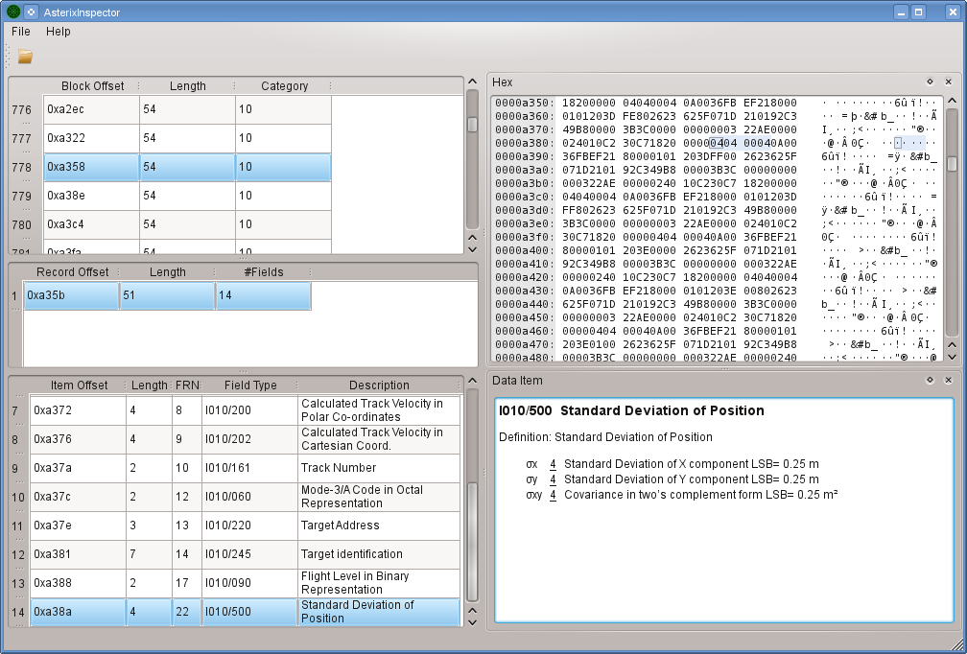
Figure 2: screenshot of the Asterix Inspector.

Both the DSB and the AAIU have programs written for the specific goal of using ASTERIX data for accident investigation. Because of the dynamic nature of accident investigation an adaptable in-house tool can create specific results for an investigation. The DSB has developed specific tools for Amsterdam Schiphol Airport and a general tool for analyzing the radar data for the Netherlands. The AAIU have developed tools to analyse two categories of data from all radar sites nationally as well as a specific tool for the multi-lateration data available at Dublin Airport.

To analyze the ASTERIX data one must first find the CAT octet of the category of data of interest. The CAT octet can be compared to a flight data recorder sync code and this methodology is similar in the way FDR data is analyzed. Because the ASTERIX data format is flexible once a tool was developed to analyze one category the same programming framework can be used to read-out other categories. The development of readers for other categories were made with less effort and validated rapidly.

Although the ASTERIX format is described in EUROCONTROL documents the range of different raw data formats provided to the DSB and AAIU have been fascinating. Both authors have had their share of exotic formats which when looked at closely did contain ASTERIX formatted data but oftentimes wrapped in proprietary formats intended for other purposes e.g. proprietary video replay systems . The difference in the equipment used by the air traffic service provider have resulted in exporting the same ASTERIX category data in a widely different data formats. Once the format is understood the data provided can be transformed for investigative purposes.

Conclusions and recommendation: Tools available at the air traffic service provider can be used for investigation purposes. A replay of data on a terminal or for example Albatross display can give a good insight. However when detailed analyses is required specific programs should be used to process the recorded data.

Event reconstruction: creating information layers

For the detailed analyses the data is converted and displayed as an information layer. This layer is not to the same as the controllers display data. In most cases the accident investigator is interested in a different set of data to that used by the radar controller. Also a three-dimensional visualisation of the data is often more insightful.

Three examples of an information layer will be given. The first is an example typical of the analyses of traffic flow. The second example will examine the possibility of incorporating weather information.
The third example will give an overview of the application of ground radar in an investigation.

Figure 3: overview of the transformation process of radar data into an information layer.

Flow of traffic
During the early stages of a major investigation conducted by the DSB in 2009 the media and other sources suggested that a commercial aircraft had crashed due to wake vortex (turbulence) from a preceding aircraft. In this particular investigation the DSB followed normal procedure and requested the data from all available radars and in all available categories. Using in-house analysis tools the data was transformed to examine the wake vortex theory.
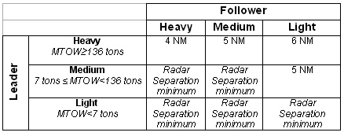
Table 1: ICAO distance-based separation minima for the approach
In examining literature and ATC the DSB were aware of tests that were conduced to enhance radar displays with a Wake Vortex Vector (WVV). The tests evaluated the WVV information which was presented as an enhancement on the controller Plan View Display (PVD). In essence the WVV is a vector trailing a target (aircraft), indicating the prescribed separation distance. Although the WVV enhancement is still in its testing phase and being evaluated the principle and theory may have future application(s) in accident investigation.
Using this knowledge the distances between all the aircraft which were on approach during the event flight were calculated and analyzed Recorded aircraft positions together with geometric calculations were displayed and analyzed for possible wake turbulence effects. Using the ASTERIX data the wake turbulence hypothesis was examined at an early stage of the investigation and found not to be a contributing factor. The use of ASTERIX data was convenient as there was no need to download, correlate and analyze 4 flight data recorders.
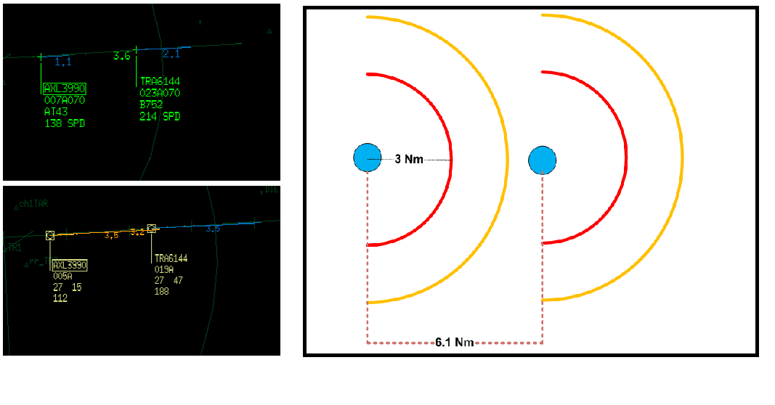
Figure 4: Left (top); Example of two targets on a PVD display with a Wake Vortex Vector (blue) of 1.1 and 2.1 Nm. Left (bottom); Example of a 3.5 Nm Wake Vortex Vector (orange) with and actual distance of 3.2 Nm between aircraft. Right; Distance calculation using ASTERIX data between aircraft on approach 6.1 Nm for accident investigation purposes. A 3and 5 Nm distance ring indicate procedures established for this case.
Conclusions and recommendation: In cases where distance calculations between different aircraft are required ASTERIX data will allow for a fast and easier analysis. Using programs which read ASTERIX data may validate or discount hypotheses at an early stage of an investigation.
Incorporating meteorological information
Weather forecasting is an integral part of aviation.. TAF (prediction) reports and METAR ( time interval weather ‘point’ measurement) are routinely used for accident investigation. However depending on the sampling rate and area of reporting these reports may be inaccurate at times.
Using aircraft ADS-B, meteorological information like the air temperature, wind velocity and direction are transmitted by aircraft. This ADS-B message is recorded in CAT 21 Item 220 which can be combined with the aircraft (GPS) position and altitude resulting in an information layer containing temperature, wind speed and wind direction. This general overview for wind and temperature can be useful when investigating weather related events. However, ideally an accident investigator would like to have the ‘now cast’ or real time weather for an area around the event during a certain period of time. If this was available the presentation of the weather would allow for improved event reconstruction.
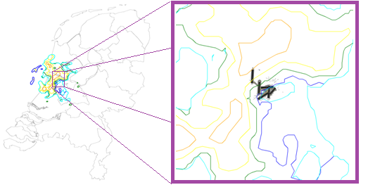
Figure 5: CAT08 weather picture of the Netherlands (Left) and detailed view of Schiphol Airport (EHAM) showing the rain areas (Right).
ASTERIX CAT08, Transmission of Monoradar Derived Weather Information, contains data regarding precipitation zones. A precipitation zone is represented by a set of consecutive summit points which constitute a closed area contour. This contour describes the area and intensity of precipitation, and each intensity level can be coupled to a different colour for presentation purposes.
In a DSB investigation the information from the weather radar was obtained and analysed. Although the controller has the capability to overlay weather information, the overlay update rate was determined to be once a minute. Analyses of the weather radar data showed the radar was providing information every 12 seconds. For the controller overlay the weather data for a period of time was interpolated and subsequently outputted to the controller display. This interpolation of data is another example of the difference in the controller display and actual raw (investigator view) data. The 12 second weather imagery can be combined with the flight track position data was used for the investigation. This reconstruction substantiated (and quantified) the pilot account of heavy rain experienced during the approach.
Furthermore it gave investigators an insight into why particular runways were in use as the runway configuration during the event was exceptional. Analyses of the precipitation zones showed that areas of high precipitation intensity were just overhead the approach paths for two of the runways which would normally be in use. The explanation of runway usage found by reconstruction and the precipitation analyses were later confirmed by controllers.
Conclusions and recommendation: Evaluation of the weather radar (precipitation) data in this investigation showed additional data was available enhancing understanding of the event. Furthermore, analyses of the radar data gave insights into runway usage which did not come to light during controller interviews.
If possible an overlay of precipitation should be made as it can help in the better understanding of the event. It is recommended to verify the different intensity levels and range of the weather radar as these are individual radar settings.
Using ground radar
In the past airport surface surveillance was accomplished by means of a rapid rotating antenna. The antenna was typically mounted on top of the control tower for optimum view of the airport surface. Unfortunately as infrastructural developments at many airports meant that the radar’s line of sight became compromises by, for example, terminal buildings, hangars, etc) obstructing the antenna’s view of movement areas. This problem was addressed by advanced systems, called A-SMGCS (Advanced Surface Movement Guidance and Control Systems) . The A-SMGCS system still uses the primary radars (SMR) to detect ground movement but it is enhanced by additional sensors. These sensors mitigate the limitations, shadowing effects or multiple reflections, which can adversely affect the primary radar. The Advanced Surface Movement Guidance and Control Systems (A-SMGCS), is currently being deployed at many of the world’s major airports. The A-SMGCS data is transmitted as ASTERIX CAT11.
Using CAT11 an overview of airport surface movement can be obtained. In addition if airport vehicles are equipped with ‘transponders’ they can be tracked in the same way as aircraft. The so-called ‘cooperative mobile’ is equipped with systems (transponders) capable of automatically and continuously providing information including its Identity to the A-SMGCS system. The ground radar data is sensed and recorded every second (1Hz) which allows for a high fidelity information layer.

For runway incursions the ground radar can be a valuable tool in the reconstruction of the event. The ground radar allows Investigators to replay the event and can be combined with audio recordings to provide valuable information. Furthermore this data can be used to create a timeline of the rescue vehicles and airport assistance after an event. This information is particular useful when investigating the performance of the emergency services in the aftermath of a rescue effort.

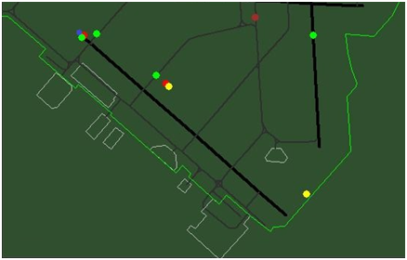
Figure 6: Example of ground radar. Top left, aircraft (blue) after an runway (black) overrun event at Schiphol. Other vehicles include: fire rescue (red), ambulance (yellow) and airport assistance vehicles (light green).

When the (onboard) flight recorder data and the A-SMGCS data are compared on a common time base differences will be observed. This is especially true for broadcast GPS position data. The on-board “time of position measurement” is recorded on the FDR but not transmitted as this message format does not comprise the respective data item. The (receiving) ground station does provide a time stamp but this is the’ time of reception’. Due to processing and transmission the time of reception may be up to two seconds later than the time of measurement onboard the aircraft. This time latency is not constant and may actually vary continuously. This latency is the same system timing delay issue previously discussed by Roberts, et al. However for events involving two or more targets (aircraft or ground vehicles) the radar data’s common time base is a distinct advantage and the latency is not a concern as it is the same for all targets.
Figure 7: Explanation of difference in time-position between flight data recorder and ASTERIX data.

In a recent DSB investigation (ground event) noticeable ‘time’ differences between obviously identical aircraft information were present. The variation of aircraft track data (positions) was minimal, the time difference on the other hand was calculated to be just under 2 seconds. This example shows that care must be taken when identical information of two distinct data sources, in this case the FDR and ASTERIX, are being correlated and fused together. In CAT 21 ADS-B category, aircraft GPS data and the ‘time of reception by ground station’ is included. This indicates that EUROCONTROL has also identified similar issues in correlation of data and processing.
Conclusions and recommendation: The use of ground radar is very useful during ground event investigations. The high update rate and accuracy of ground radar will facilitate a high fidelity reconstruction. Care must be taken when fusing other sources of data, for example the FDR, as time differences may exist.
Conclusion
ASTERIX is a flexible data format which can be processed to aid accident investigators in answering investigative questions. Understanding the ASTERIX data format and its capabilities make it possible to write programmes to adapt ASTERIX in a way beneficial to an investigation. Depending on the type of accident ASTERIX data may be helpful in establishing a timeline, putting the event in a weather context and providing additional insight(s). The table below, although not complete, shows the categories the DSB and AAIU have identified which are useful and have benefits to use in accident investigations.
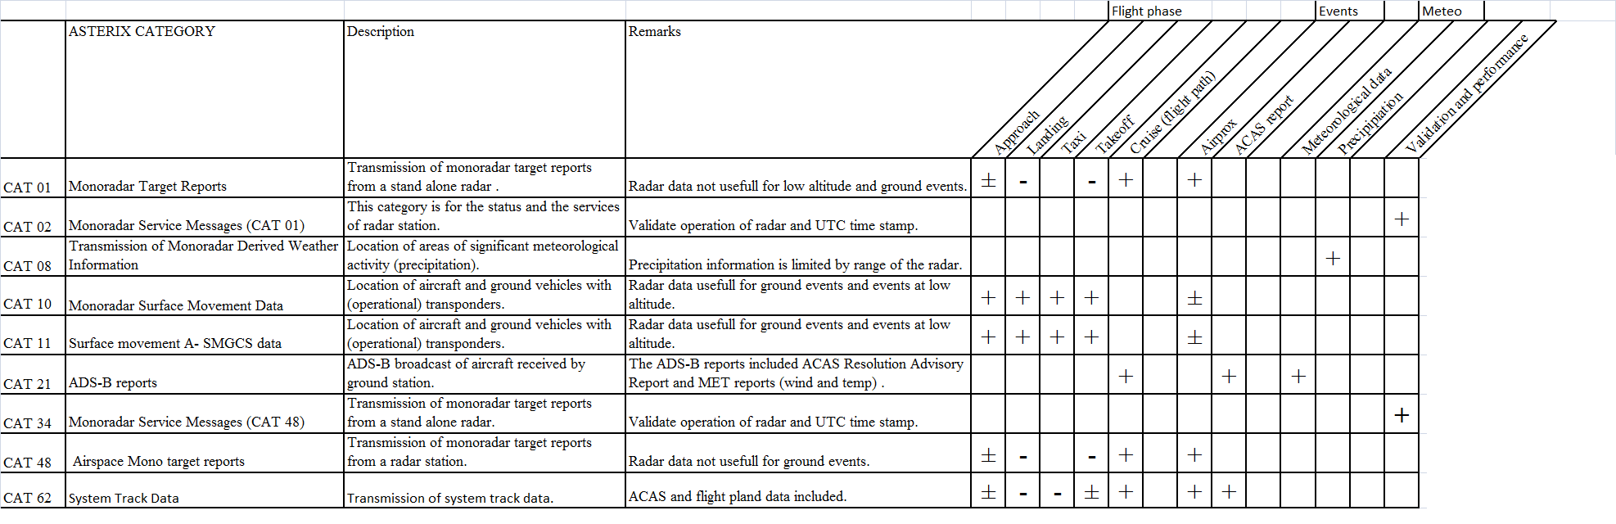
Figure 8: Overview of ASTERIX categories and quantitative indication of the data category which aid in a specific type of investigation or phase of flight.

http://www.eurocontrol.int/asterix/public/subsite_homepage/homepage.html
http://www.eurocontrol.int/asterix/public/standard_page/philosophy.html
http://www.eurocontrol.int/asterix/public/standard_page/asterix_cats.html

